A

PROJECT REPORT

ON

**VR Horror Game**

Submitted in partial fulfillment of the requirements of the degree of

**Bachelor of Engineering**

**In**

**Information Technology**

by

Ritvik Babre - 5

Hitesh Behera - 6

Shruti Sabbani - 50

Swapnil Yadav - 67

Supervisor(s):

Asst. Prof. Punam Bagul



**Department of Information Technology**

K.C. College of Engineering and Management Studies And

Research, Thane (E)

University of Mumbai

2023-24

**CERTIFICATE**

This is to certify that the project entitled “ **VR Horror Game** ” is a bonafide work of “**Ritvik Babre - 5 , Hitesh Behera - 6 , Shruti Sabbani – 50 , Swapnil Yadav - 67**”submitted to the University of Mumbai in partial fulfillment of the requirement for the award of the degree of **“Bachelor of Engineering”** in **“Information Technology”**.

Asst. Prof. Punam Bagul Asst. Prof. Aarti Abhyankar

Supervisor/Guide Co Supervisor/Guide



Prof. Amarja Adgaonkar Dr. Vilas Nitnaware

Head of Department Principal

**Project Report Approval for B.E.**

This project report entitled ***VR Horror Game*** by ***Ritvik Babre - 5, Hitesh Behera - 6, Shruti Sabbani - 50, Swapnil Yadav - 67*** is approved for the degree of Bachelor of Engineering in **Information Technology.**

Examiners

1.---------------------------------------------

2.---------------------------------------------

Date:

Place:

**DECLARATION**

We declare that this written submission represents our ideas in our own words and where others' ideas or words have been included, we have adequately cited and referenced the original sources. We also declare that we have adhered to all principles of academic honesty and integrity and have not misrepresented or fabricated or falsified any idea/data/fact/source in my submission. We understand that any violation of the above will be cause for disciplinary action by the Institute and can also evoke penal action from the sources which have thus not been properly cited or from whom proper permission has not been taken when needed.

_________________________

Ritvik Babre – 5

Hitesh Behera – 6

Shruti Sabbani – 50

Swapnil Yadav – 67

Date:

**ACKNOWLEDGEMENT**

We would like to express special thanks of gratitude to our guide **Asst. Prof. Punam Bagul** who gave us the golden opportunity to do this wonderful project on the topic of VR Horror Game, which also helped us in doing a lot of research and we came to know about so many new things. We are very grateful to our Head of the Department **Prof. Amarja Adgaonkar** for extending her help directly and indirectly through various channels in our project work**.** We would also like to thank I/C Principal **Dr. Vilas N Nitnaware** for providing us the opportunity to implement our project. We are really thankful to them. Finally we would also like to thank our parents and friends who helped us a lot in finalizing this project within the limited time frame.

Thanking You.

**TABLE OF CONTENT**

**Sr.No. Topic Page No.**

**Certificate ….………….……………………………………. 2**

**Approval Sheet …..…………………………………………. 3**

**Declaration   ………………………………………………….. 4**

**Acknowledgement ………………………………………..… 5**

**List of Figures ...……………………………………………… 7**

**List of Tables .………………………………………………… 8**

**Abstract ...…………………………………………………… 9**

1. **Introduction ………………………………………………………… 10**
2. **Review of Literature ………………………………………………… 11**
3. **Proposed Work 13**

3.1. Requirement Analysis ………………………………

* + 1. Scope ……………………………… 13

3.1.2 Feasibility Study ……………………… 14

3.1.3 Hardware & Software Requirement ……….. 15

3.2 Problem Statement …………………………………………… 16

3.3 Project Design …………………………………………………. 17

3.4 Methodology…………………………………………………… 18

3.5 Implementation………………………………………………… 20

**4**. **Test Cases………………………………………………………………**

**5**. **Conclusion and Future Scope………………………………………… 25**

**References……………………………………………………………. 26**

**Publications by the candidate……………………………………….. 27**

**LIST OF FIGURES**

|  |  |  |
| --- | --- | --- |
| Figure No. | Name of the figure | Page No. |
| 3.3.1 | DFD Level 0 | 22 |
| 3.3.2 | DFD Level 1 | 22 |
| 3.3.3 | Class Diagram | 23 |
| 3.3.4 | Game Architecture | 23 |
| 3.4.1 | Game Mechanism | 25 |
| 3.5.1 | Gyroscopic head tracking flowchart | 26 |
| 3.5.2 | Random Item Spawner | 27 |
| 3.5.3 | Enemy AI Behaviour Flowchart | 28 |
| 3.5.4 | Enemy in PATROL State | 29 |
| 3.5.5 | Enemy <Animator> Component | 29 |
| 3.5.6 | Stereoscopic Game Interface | 30 |

**LIST OF TABLES**

|  |  |  |
| --- | --- | --- |
| Table No. | Name of Table | Page No. |
| 2.1 | Literature Survey | 11 |
| 3.1 | Hardware & Software requirements | 19 |
| 4.1 | Test Cases | 31 |

**ABSTRACT**

The horror game serves as a medium to introduce VR and integrate as a technology into everyday life as a lifestyle choice. Through immersive environments, we aim to showcase the transformative potential of interactive computing. Virtual reality (VR) horror games offer an unparalleled immersion by leveraging first-person perspective, realistic graphics, and interactive gameplay. Players experience the game world through the eyes of the protagonist, enhancing the feeling of presence and intensifying the horror experience. Detailed environments, coupled with atmospheric lighting, create a sense of dread, while interactivity allows players to manipulate objects and solve puzzles. This VR horror game offers an approachable entry point into the immersive world of virtual reality.

Virtual reality offers a unique and immersive experience that allows users to interact with digital environments in a way that feels incredibly realistic. VR provides a sense of presence and immersion, allowing users to feel like they are physically present in a virtual environment. Gaming is a powerful tool for promoting virtual reality technology because through VR gaming, users can experience firsthand the sense of presence and immersion that VR offers, leading to greater interest and enthusiasm for the technology.

**INTRODUCTION**

The VR horror game, crafted with the purpose of showcasing VR's capabilities and its associated advantages such as immersive experience and entertainment.

One way to introduce VR technology to a wider audience is to develop VR games. Gaming being one of the biggest industries in the world will allow VR to get a platform where it can showcase its endless possibilities to the world. Horror Games are some of the biggest games in the industry as they allow the player to get immersed with the environment. This makes the horror genre one of the best genres to showcase the capability of VR.

The game may have a cultural impact by influencing perceptions of VR technology and shaping immersive gaming experiences. Through innovative storytelling and gameplay mechanics, the game contributes to shaping the narrative surrounding VR and its potential impact on entertainment and society.

By promoting VR technology through a popular gaming genre like horror, the game contributes to expanding the market for VR hardware and software. It attracts new players to the VR ecosystem and encourages existing gamers to explore the possibilities of VR gaming.

**2. Review Of Literature**

Table No. 2.1. Literature Survey

|  |  |  |  |  |  |
| --- | --- | --- | --- | --- | --- |
| Sr. No. | Title | Authors | Methodology | Advantages | Results |
| 1 | Virtual Reality Horror Games and Fear in Gaming (2023) | Tammy Jin-Hsuan Lin | -Evolutionary mechanism,  -Excitation transfer theory and model of suspense  -Three-factor model | -Immersion in VR  -Audience Experience  -Valueable insights to human behaviour and emotions  -Interactive Storytelling | -Deeper understanding of human behavior & media effects  -Helps address various phobias |
| 2 | Research on the Application of VR in Games (2023) | Shijie Bian | -Appliaction of VR in Horror, Role-Playing and Rhythmic games | -Strong sense of immersion  -Realistic environments and gaming experience  -Enhanced fun and entertainment | -Scope of VR  -Future Gaming experience  -Evolution of VR in Games |
| 3 | Research on the Progress of VR in Game (2023) | Ruiqi Zhang | -Application in VR in Action Simulation, Education, Scenario experienced Games | -Enhanced gaming experience  -Improved teaching  -Enhanced Immersion | -Strong Game Immersion  -Real time human- machine interaction  -Analysis of trends and characteristics |
| 4 | Adaptive virtual reality horror games based on Machine learning and  player modeling (2022) | Edirlei Soares de Lima , Bruno M.C. Silva , Gabriel Teixeira Galam | -Conceptual Framework Development  -Machine Learning Algorithms  -Player Modeling  -Adaptive Game Design  -Evaluation | -Personalized Gaming Experience  -Enhanced Immersion  -Optimized Gameplay  -Improved Player Retention  -Innovative Game Design | -Effectiveness of Adaptive Features  -Impact on Player Behavior  -Player Satisfaction and Retention  -Performance Metrics  -User Feedback and Preferences |
| 5 | Analysis Of The Design  Aesthetics And Player  Emotions Of Horror  Games (2022) | Ziwen Zhang | -Qualitative research  - Quantitative research  - Biometric measures | - Triangulation enhances  validity & reliability of  results.  - Combining approaches  increases accuracy,  strength, & generalizability.  - Corroborates & crossvalidates  results.  Decreases biased  interpretation. | - Horror games evoke  emotions such as fear &  excitement.  - The number of  experienced players  affects players' comfort &  overall mood.  - Players' satisfaction with  the game depends on  factors such as a sense of  achievement, excitement  & puzzle-solving. |
| 6 | Horror game design – what  instills fear in the player? (2020) | Mikolaj Dymek | - Dark environments  - Environmental  design, sound design,  lighting, & gameplay  narrative.  - Auditory  hallucinations, such as  human screams | - Dark environments  - Environmental  design, sound design,  lighting, & gameplay  narrative.  - Auditory  hallucinations, such as  human screams | Horror game design  theories can be successful  in scaring players when  combined with level  design & navigation  patterns.  Litreature Survey | VR Horror Game using Unity |
| 7 | “Level Of Fear”: Analysis  Of Fear Spectrum Into a  Tool To Support Horror  Game Design For  Immersion And Fear (2018) | Konstantinos  Ntokos | -Level of Fear  -Analyze Fear into  Spectrum  -Communication &  Collaboration  -Pacing & Relief  Injections | Tool for measuring fear in  horror games  - Helps developers calibrate  difficulty & scariness  - Plots intensity levels  throughout the game  - Classifies in-game  elements based on their  "level of fear" | - Tool to measure &  categorize fear in horror  games  - Helps developers  calibrate difficulty &  scariness  - Plots intensity levels of  fear  - Marks fear levels of  different game  components |
| 8 | So scary, yet so fun: The role of self-efficacy in enjoyment of a virtual reality horror game (2017) | Jih-Hsuan Tammy Lin , Dai-Yun Wu , Chen-Chao Tao | -Experimental Design  -Measurement of Enjoyment  -Quantitative & Qualitative Data Collection  -Ethical Considerations | -Insights into Psychological Factors  -Relevance to VR Gaming Industry  -Methodological Rigor  -Practical Implications  -Interdisciplinary Collaboration | -Positive correlation between self-efficacy and enjoyment  -Impact of self-efficacy on immersion  -Differences based on experience  -Implications for game design |

**3. Report on Present Investigation**

**3.1. Requirement Analysis:**

**3.1.1. Scope**

The VR horror game is crafted with the purpose of showcasing VR's capabilities and its associated advantages such as immersive experience and entertainment.

One way to introduce VR technology to a wider audience is to develop VR games. Gaming being one of the biggest industries in the world will allow VR to get a platform where it can showcase its endless possibilities to the world. Horror Games are some of the biggest games in the industry as they allow the player to get immersed with the environment. This makes the horror genre one of the best genres to showcase the capability of VR.

The game may have a cultural impact by influencing perceptions of VR technology and shaping immersive gaming experiences. Through innovative storytelling and gameplay mechanics, the game contributes to shaping the narrative surrounding VR and its potential impact on entertainment and society.

By promoting VR technology through a popular gaming genre like horror, the game contributes to expanding the market for VR hardware and software. It attracts new players to the VR ecosystem and encourages existing gamers to explore the possibilities of VR gaming.

**3.1.2. Feasibility study**

The feasibility study is a major factor which contributes to the analysis and development of the game. Feasibility study is undertaken whenever there is a possibility of improving the existing game or designing a new system. Feasibility study helps to meet user requirements. With the VR Horror Game feasibility study we’ll identify the market demands and cost-effective path forward.

1. **Market Analysis:**

* Age Group: Identify the age groups most interested in horror games and VR experiences. This may include teenagers, young adults, and older gamers.
* Customer Size: Estimate the size of the target market by considering the number of VR headset owners, horror game enthusiasts, and potential new adopters of VR technology.
* Market Demand: Evaluate the demand for VR horror games based on search trends, social media discussions, and sales data of existing VR horror titles.
* Market Trends: Stay informed about trends in the VR gaming industry, including advancements in VR technology, emerging gameplay mechanics, and popular themes within the horror genre.
* Current Trends: Assess current trends in horror gaming, such as the popularity of immersive storytelling, atmospheric experiences, or multiplayer/cooperative gameplay.
* Budget Power: Determine the purchasing power of the target audience by considering factors such as disposable income, willingness to spend on entertainment, and affordability of VR hardware.
* Localization: Assess the potential demand for localized versions of the VR horror game in different regions and languages.

**Technical feasibility:**

* High Computational Power: Determine the computational demands of the game, AI behavior, and real-time rendering calculations. Optimize game mechanics to balance computational complexity with performance efficiency, ensuring smooth gameplay on a variety of hardware setups.
* Rendering: Implement rendering techniques optimized for VR, such as stereoscopic rendering, lens distortion correction, and asynchronous timewarp.
* Power Usage: Consider power consumption constraints for VR hardware, particularly for standalone VR headsets and mobile devices. Implement power-saving features such as dynamic clock scaling, background resource management, and display brightness adjustments to optimize power usage during gameplay.
* Bandwidth: Evaluate the bandwidth requirements for downloading and streaming VR content, including textures, audio files, and streaming assets.

**Financial Feasibility:**

* Hardware Cost: Evaluate the cost of VR hardware required to play the game, including VR headsets, gamepad controllers, Android device with a gyroscope sensor and compatible gaming PCs or consoles.
* Entry Cost: Evaluate the total cost of entry into the VR horror game, including the purchase price of the game itself and any additional expenses such as VR hardware, accessories, or subscriptions.
* Spending Power: Consider the target audience's spending power and affordability when determining hardware requirements and performance expectations.

**Legal Considerations:**

* Copyrights: Obtain necessary permissions or licenses for any third-party content used in the game, such as music tracks, sound effects, or visual assets. Register copyrights for original creative works associated with the game, such as character designs, concept art, and story scripts, to protect against unauthorized use.

**3.1.3. Hardware and Software requirements**

Table No. 3.1 Hardware & Software requirements

|  |  |
| --- | --- |
| Hardware | Software |
| Android device | Google cardboard SDK |
| Gyroscope | Game Engine - Unity |
| Gamepad Controller | Version Control System - GitHub |
| VR Headset | Scripting Language – C# |
|  | IDE – Visual Studio |

**Hardware Requirements:**

* **Android Device**: An Android device can serve as a platform for VR horror games, leveraging its processing power and display capabilities to provide immersive experiences through compatible
* **Gyroscope**: The gyroscope enables precise motion tracking in VR horror games, enhancing immersion by accurately detecting head movements for a more realistic experience.
* **Gamepad Controller**: The Gamepad controller is a hand-held device that makes gaming easier and more fun with its buttons and joysticks and enhances player interaction in VR horror games, providing intuitive input for navigating environments and engaging with immersive gameplay mechanics.
* **VR Headset**: The VR headset immerses players in virtual world using the lenses attached to it and the screen of the Android device that the user is using.

**Software Requirements:**

* **Google Cardboard SDK**: Transform your Android device into a virtual reality headset, offering immersive experiences with stereoscopic rendering and head tracking.
* **Unity Game Engine**: Unity serves as the ideal game engine for VR game development, providing powerful tools and capabilities for creating immersive and terrifying experiences with ease.
* **Version Control System – GitHub**: It provides a user-friendly interface for managing code repositories on GitHub, facilitating collaboration and version control for Unity projects with ease.
* **Scripting Language – C#**: A powerful and versatile programming language used for building a wide range of software applications and systems.
* **IDE – Visual Studio**: A versatile integrated development environment (IDE) equipped with powerful tools for software development across multiple platforms.

**3.2 Problem Statement:**

Virtual reality (VR) is an emerging technology that has the potential to revolutionize the way we interact with games and other experiences. However, VR is still relatively new and expensive, and many people lack the understanding of how it works. This limits the reach of VR technology and prevents it from becoming an integral part of our lives.

Developing a VR horror game involves addressing significant challenges, including accessibility and affordability concerns due to the high cost of VR hardware and the niche market for VR gaming. Additionally, technical constraints such as hardware limitations, performance optimization, and platform compatibility must be overcome to ensure a smooth and seamless gameplay experience. Balancing these factors is crucial to creating an inclusive and enjoyable VR horror game that appeals to a broad audience while promoting VR and delivering immersive and engaging gameplay.

One way to introduce VR technology to a wider audience is to develop VR games. Gaming being one of the biggest industries in the world will allow VR to get a platform where it can showcase its endless possibilities to the world. Horror Games are some of the biggest games in the industry as they allow the player to get immersed with the environment. This makes the horror genre one of the best genres to showcase the capability of VR.

**3.3 Project Design:**

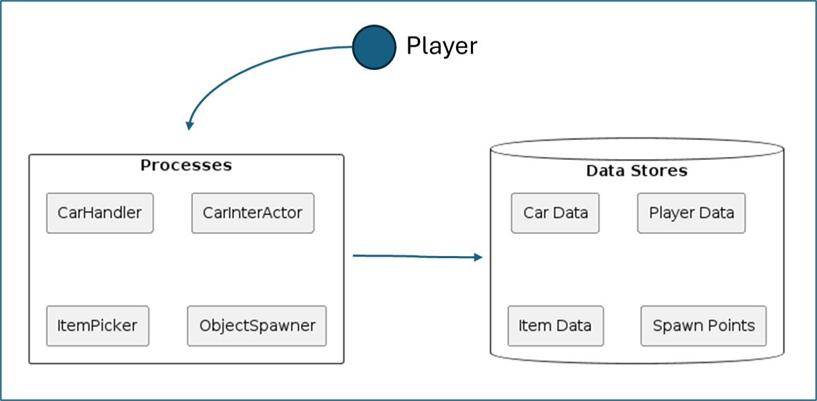

Fig. 3.3.1 DFD Level 0

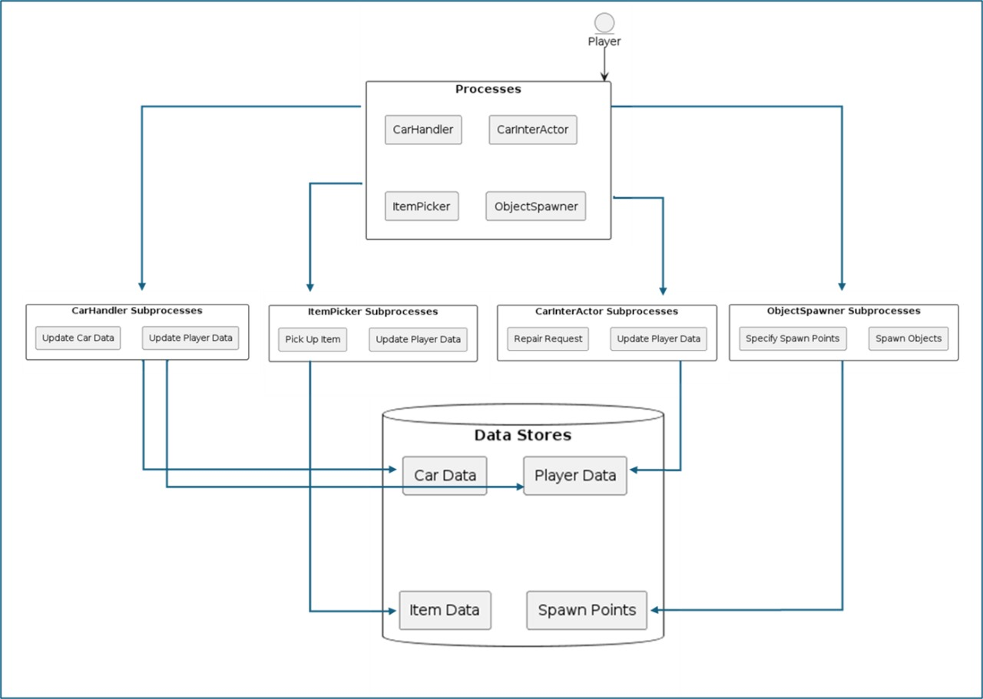

Fig. 3.3.2 DFD Level 1

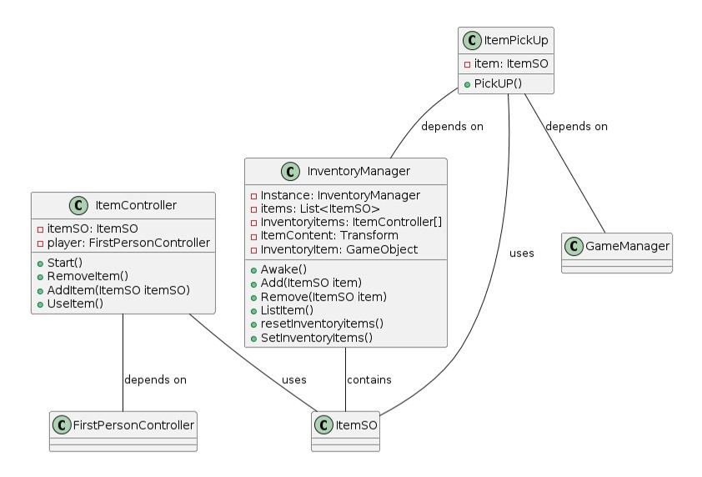

Fig. 3.3.3 Class Diagram

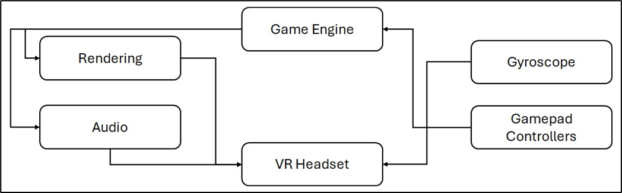

Fig. 3.3.4 Game Architecture

**3.4. Methodology**

The game is a survival horror experience, challenging players to complete all quests to achieve victory.

**1. Object Collection:** Players collect various items essential for completing tasks.

**2. AI Enemies:** Dynamic AI enemies relentlessly search players, instilling a sense of terror.

**3. Google Cardboard SDK:** Integrates VR functionalities on Android devices, including stereoscopic rendering and headtracking.

**4. Gyroscope:** Utilizes sensor data to track players' head movements.

**5. Game manager:** The central hub oversees game elements like states, UI, input, events, logic and win-loss condition. It synchronizes the elements to ensure a cohesive player experience.

**6.** **Item Spawner:** The algorithm enhances game replayability by randomly spawning items from strategically positioned points across the map.

**7. Audio Management:** 3D spatial audio and eerie sounds for a heightened atmosphere.

**8. User Interface (UI):** VR oriented UI elements provide essential information and enhance player interaction.

**9. Win Condition:** Victory is achieved by completing all tasks & escaping from enemies.

**10. Lose Condition:** When player is caught by enemies, it leads to game over.

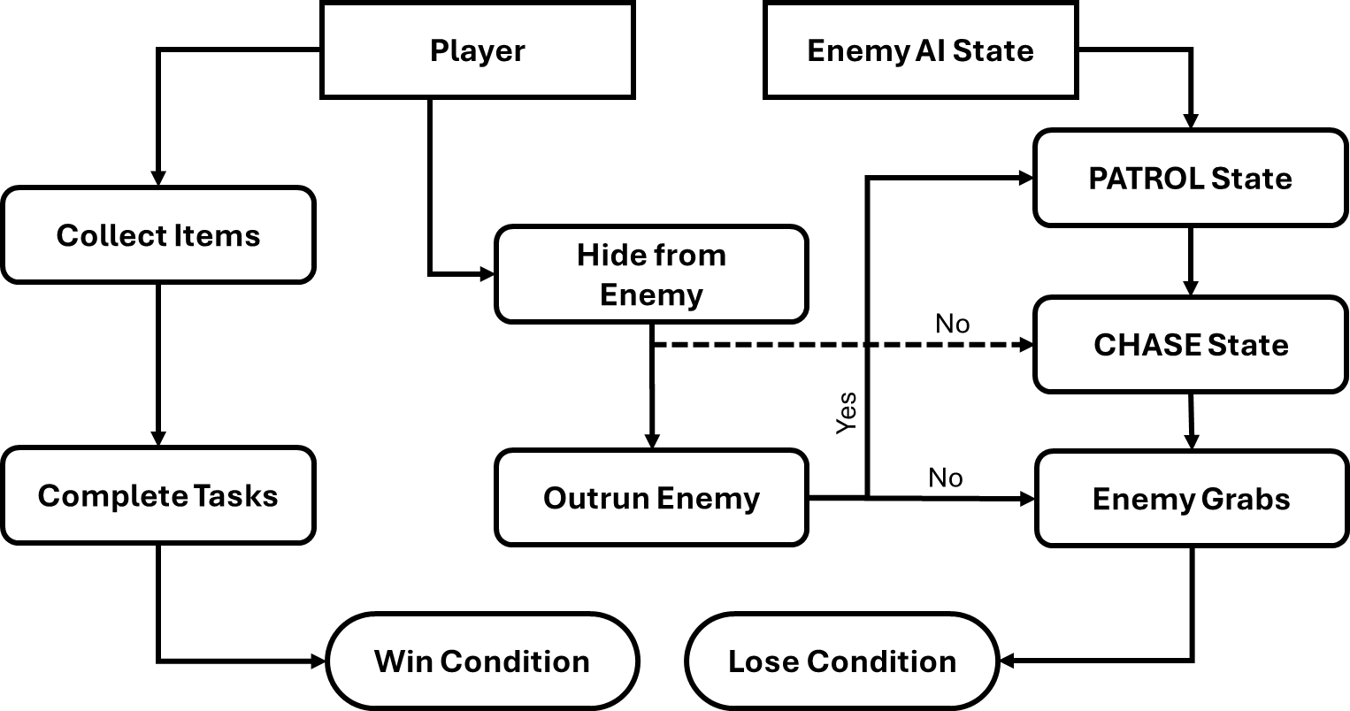  
  
Fig. 3.4.1 Game Mechanism

**3.5. Implementation**

**System Features**

HEAD TRACKING:

Head tracking in the VR horror games on Android will be implemented using Google Cardboard SDK which uses the device's built-in sensors, the gyroscope. These sensors detect the user's head movements, including rotations and tilt. Unity's Android VR integration allows to access this sensor data and update the virtual camera's position and orientation accordingly.

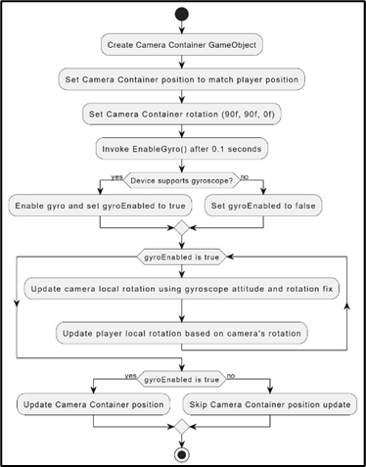

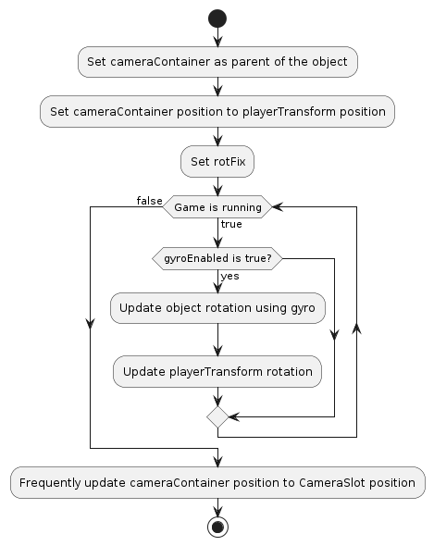

Fig. 3.5.1 Gyroscopic head tracking flowchart

ITEM PICKUP & SPAWNER:

The game uses raycasting for item pickup, enabling players to interact with virtual objects. When the player's VR camera focuses on an object, a ray is cast from the camera's position. If this ray intersects with an interactable object, players can trigger a pickup by pressing a button on their VR controller. Raycasting offers a natural and intuitive interaction method, enhancing immersion and gameplay in the VR horror experience.

The game objects spawn at specified spawn points. The game engine randomly selects spawn points from corresponding lists and instantiates objects based on the specified count, ensuring a varied and engaging gameplay experience. This approach adds randomness and unpredictability to the game world, enhancing player exploration and interaction with objects throughout the game.

Tyres and other items spawn randomly at designated positions:

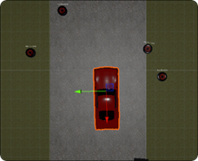 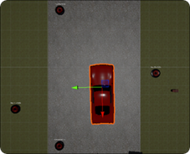

Fig. 3.5.2 Random Item Spawner

ENEMY AI:

The enemy's AI is designed with various states like idle, patrol, chase, grab, and return to patrol. These states dynamically change based on player proximity and randomized movement algorithms, creating suspenseful gameplay. To navigate the terrain, the enemy utilizes a Nav Mesh Agent for smooth movement. The patrol radius gradually reduces over time, adding strategic depth to the enemy's movements and behaviour.

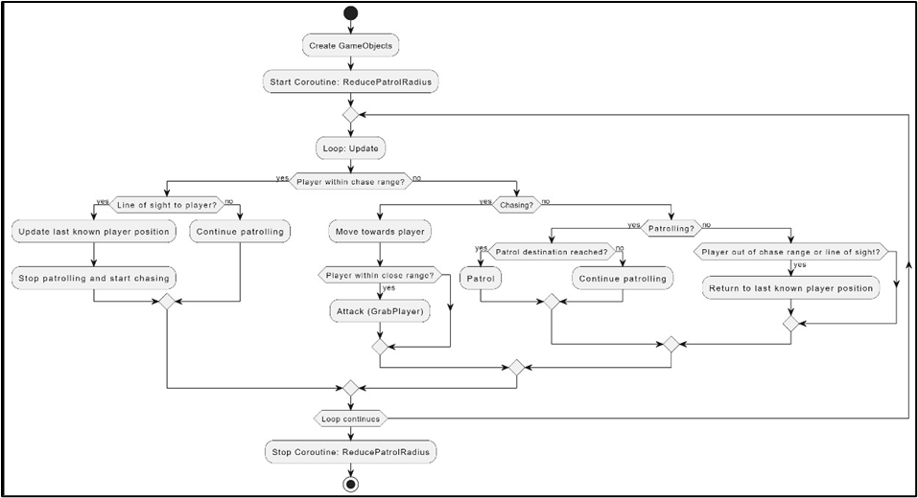

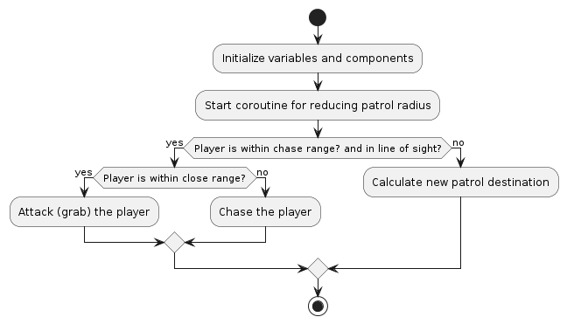

Fig. 3.5.3 Enemy AI Behaviour Flowchart

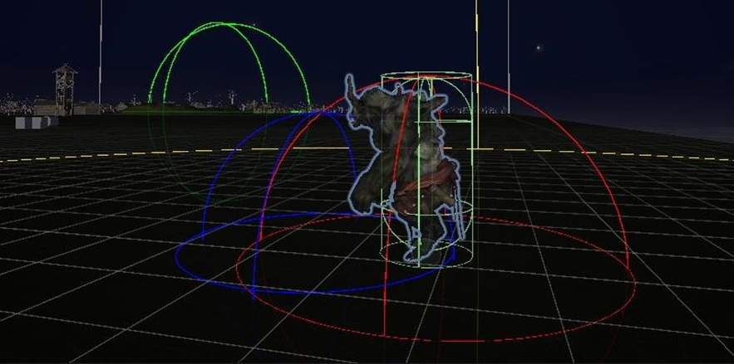

Fig. 3.5.4 Enemy in PATROL State

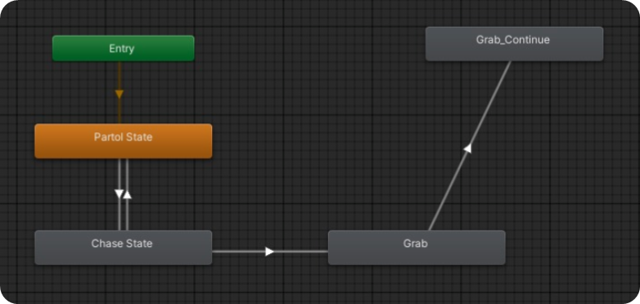

Fig. 3.5.5 Enemy <Animator> Component

GAME MAP:

Game maps play a crucial role in VR horror games as they provide players with a structured environment to navigate and explore. Well-designed maps not only guide players through the game but also prevent confusion and aimless wandering. In a VR horror game, the map is crafted with diverse topography, offering varied challenges and encounters. It includes strategically placed elements and eerie audio settings, creating an immersive atmosphere that enhancing gameplay experience.

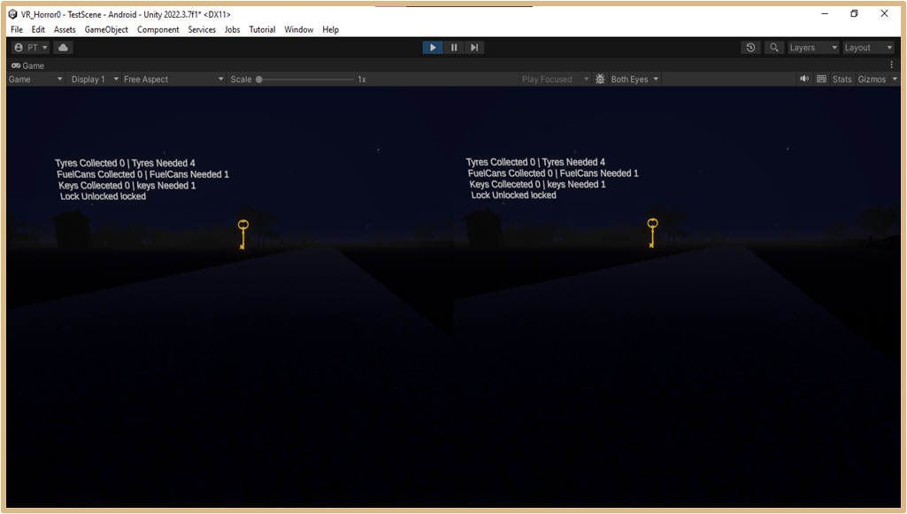

Fig. 3.5.6 Stereoscopic Game Interface

USER FEEDBACK:

Throughout developments, various testing methods are being employed, including alpha and beta testing, alongside continuous testing among the development team. Initial feedback has positively highlighted the exceptional sound design, contributing significantly to the overall gameplay experience.

1. **Test Cases**

Table No. 4.1 Test Cases

|  |  |  |  |  |
| --- | --- | --- | --- | --- |
| Sr. No. | Name | Input | Output | Type |
| 1 | Environment and Navigation | Gamepad Controller and Gyroscope | The player can navigate through the virtual environment and interact with objects in the environment using VR controllers | Functionality |
| 2 | Gameplay Mechanics | Interactive Objects, Pickable Objects, Enemy, Repairable Objects, Movement | Gameplay mechanics such as puzzle-solving, hiding from enemies. | Functionality |
| 3 | Visual and Audio Effects | Textures, Materials, Lighting, Footsteps Sound, Environmental Sounds, Enemy Audio | Visual effects create the intended atmosphere for a horror experience. | Functionality |
| 4 | User Interface and Controls | Inventory Panel, Captions, Health Bar, Journal | Ensure that the user interface elements are clear and readable in VR. | User  Interface |
| 5 | Compatibility and Integration | Android Devices, Windows | Test compatibility with different input devices to ensure consistent functionality across platforms | Usability Test |

**5. Conclusion & Future Scope**

Our VR horror game incorporates a holistic approach to gaming, seamlessly blending immersive environments with advanced technology while catering to the traditional enthusiasm for consuming horror stories. It represents a fusion of past, present, and future elements, presenting VR seamlessly into daily life experiences. Adhering to VR rules and integrating cohesive features, our game sets a new standard for immersive entertainment.

Integration of advanced comfort settings and locomotion techniques, such as teleportation, snap turning, and field-of-view adjustments, to minimize motion sickness symptoms. Implementation of dynamic storytelling elements, nonlinear narratives, and branching paths to enhance player agency and immersion in VR horror environments. Addressing concerns about eye health due to prolonged VR headset use, future VR games may incorporate features such as regular breaks, adjustable display settings, and eye-tracking technology to mitigate potential risks and promote safe VR experiences.

Expanding on multiplayer capabilities, future beginner VR horror games may introduce cooperative or competitive modes for shared immersive experiences. Additionally, offering downloadable content (DLC) can extend gameplay longevity with new levels, characters, or storylines. Optimization efforts will focus on enhancing performance across VR platforms for smoother and more immersive gameplay experiences.

**REFERENCES**

1. Zhang, Ruiqi. "Research on the Progress of VR in Game." Highlights in Science, Engineering and Technology 39 (2023): 103-110.
2. Bian, Shijie. "Research on the Application of VR in Games." Highlights in Science, Engineering and Technology 39 (2023): 389-394.
3. Lin, Tammy Jin-Hsuan. "Virtual Reality Horror Games and Fear in Gaming." In Oxford Research Encyclopedia of Communication. 2023.
4. de Lima, Edirlei Soares, Bruno MC Silva, and Gabriel Teixeira Galam. "Adaptive virtual reality horror games based on Machine learning and player modeling." Entertainment Computing 43 (2022): 100515.
5. Zhang, Ziwen. "Analysis of the design aesthetics and player emotions of horror games: Take ‘Little Nightmares’ as a case." (2022).

1. Årnell, Tobias, and Nikola Stojanovic. "Horror game design–what instills fear in the player?: A study on the effects of horror game design theories and level design patterns on player behaviour in a horror environment." (2020).
2. Lin, Jih-Hsuan Tammy, Dai-Yun Wu, and Chen-Chao Tao. "So scary, yet so fun: The role of self-efficacy in enjoyment of a virtual reality horror game." New Media & Society 20, no. 9 (2018): 3223-3242.
3. Ntokos, Konstantinos. "Level of fear”: Analysis of fear spectrum into a tool to support horror game design for immersion and fear." An International Journal (CGDEIJ) 1, no. 33-43 (2018).

**Publications by the Candidates**

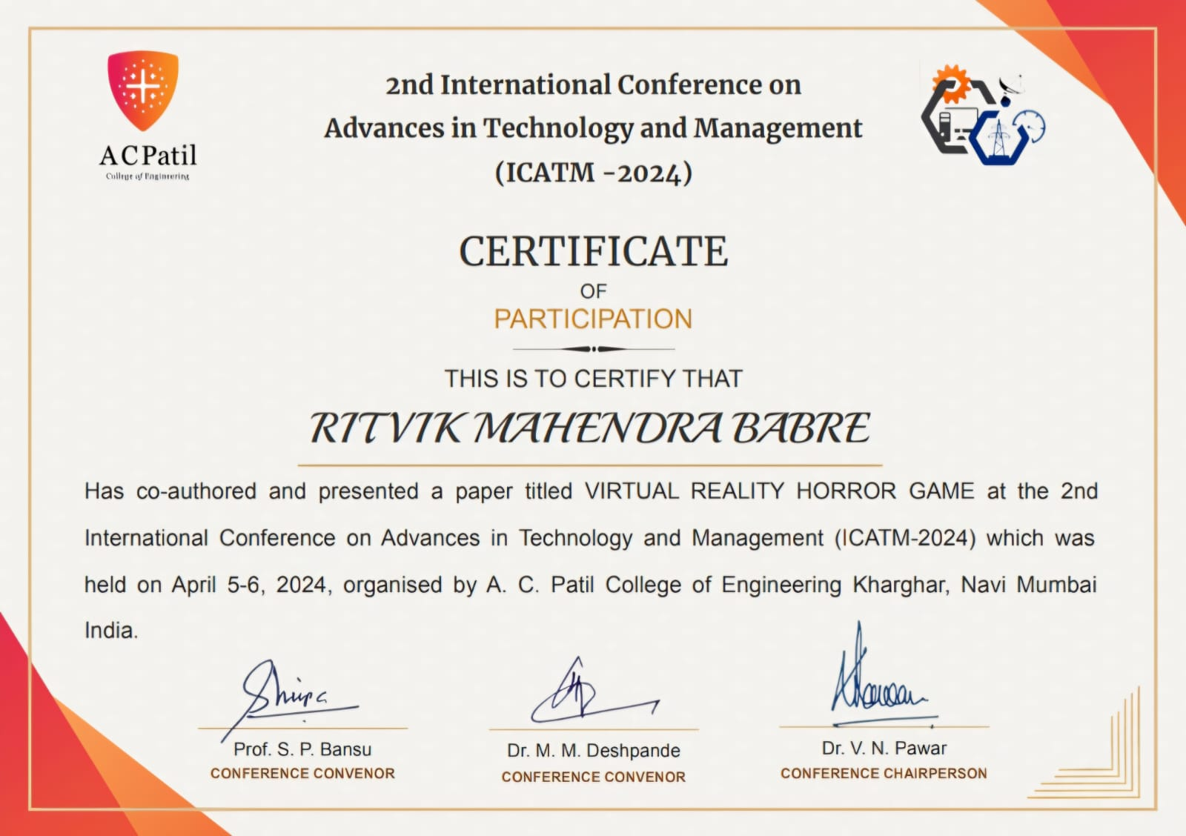

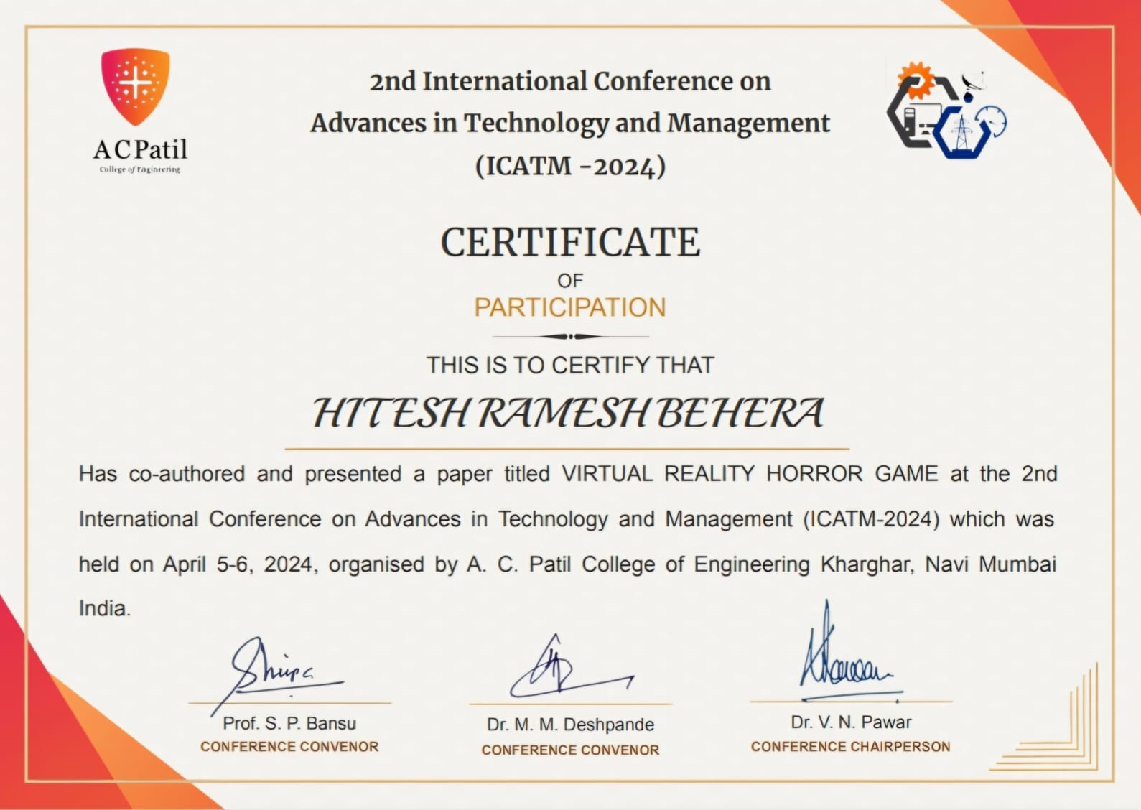

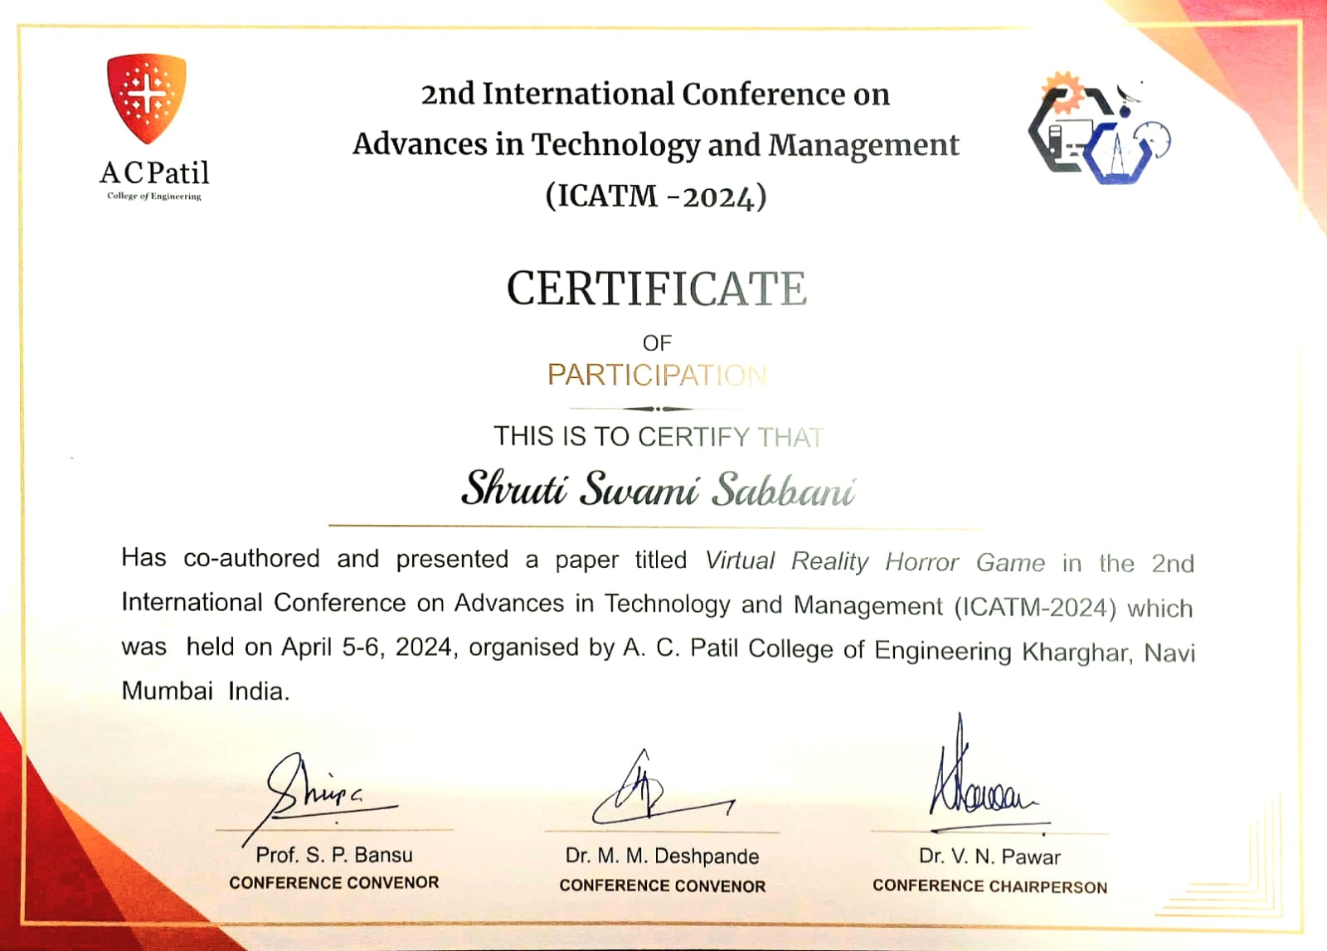

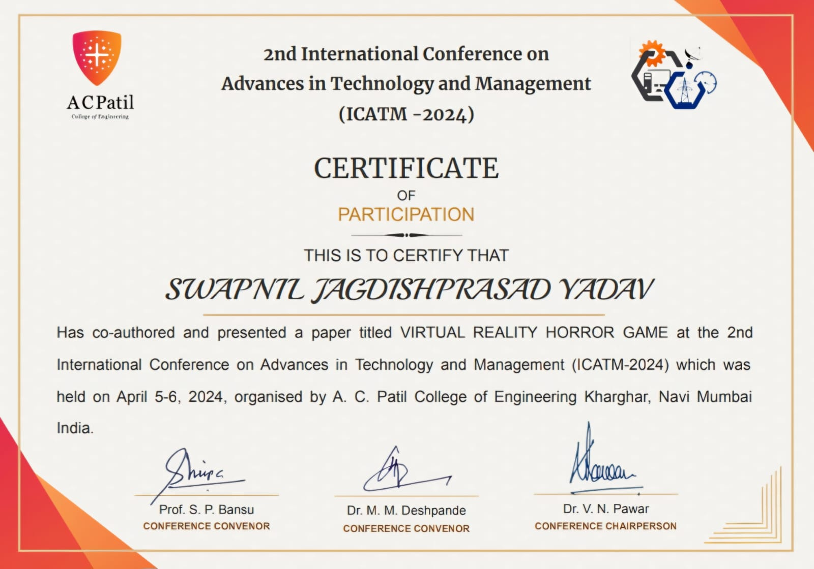

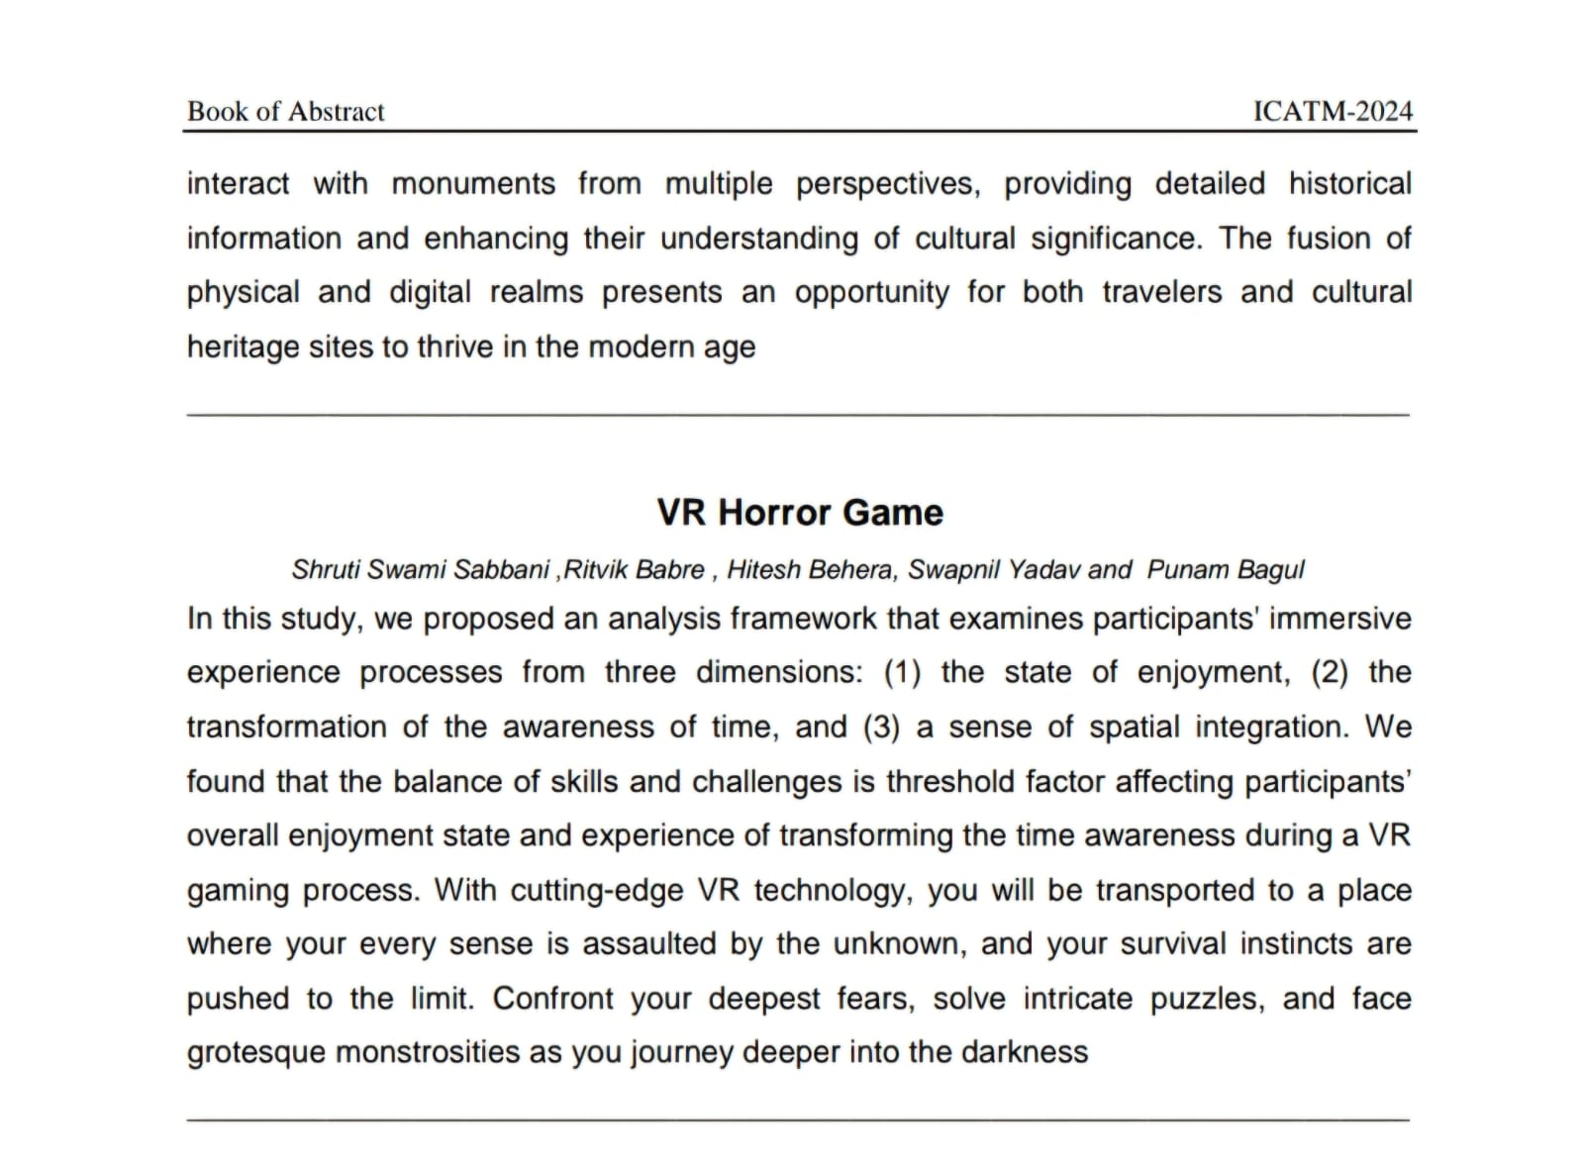

<https://icatm.in/>



  
  
  


